Lab Report 4

ESE – 3005

EMBEDDED SYSTEMS ARCHITECTURE 2

Submitted to :

Linchan Wang

Submitted by:

Jasmine (748300)

Gurvinder Singh(748418)

Rasandeep Singh(727753)

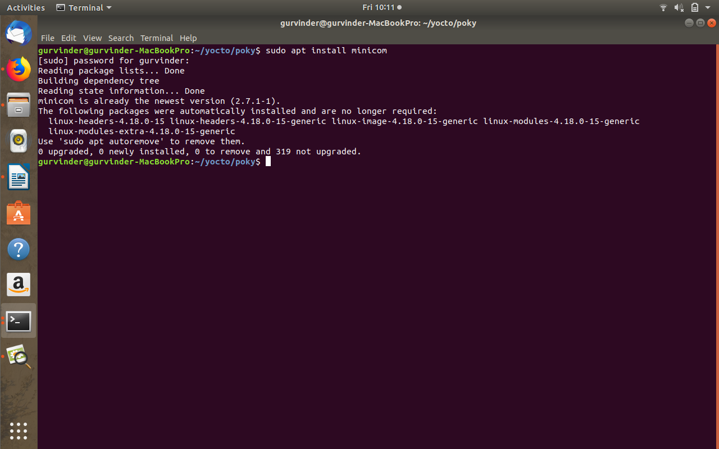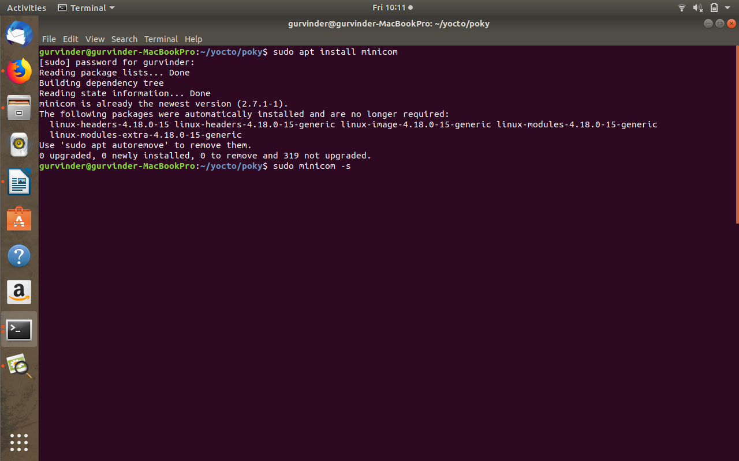Run the image (Minimal)

